Q. Create Jenkins job using declarative pipeline, We have three branch in our project repo and we need write pipeline script to clone these branches, create 3 container , 3 volumes and mount respective volume on respective container to deploy index file of respective branch on respective container httpd server through Docker volume.

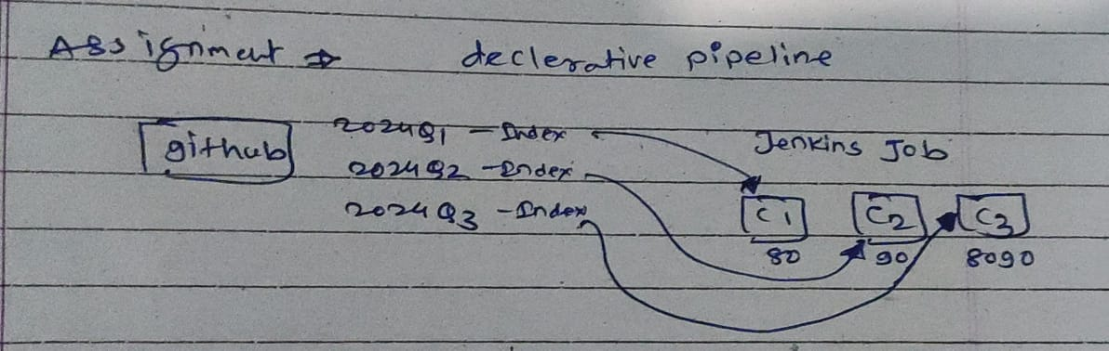

Created ec2 instance

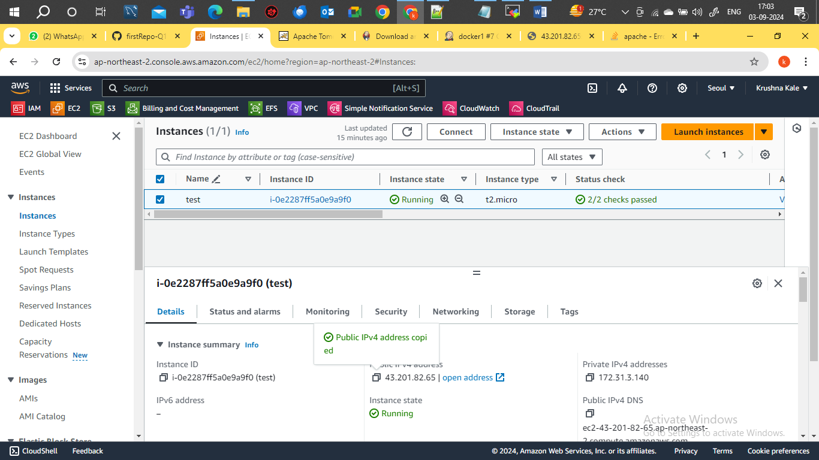

Create pipeline job Name : docker2

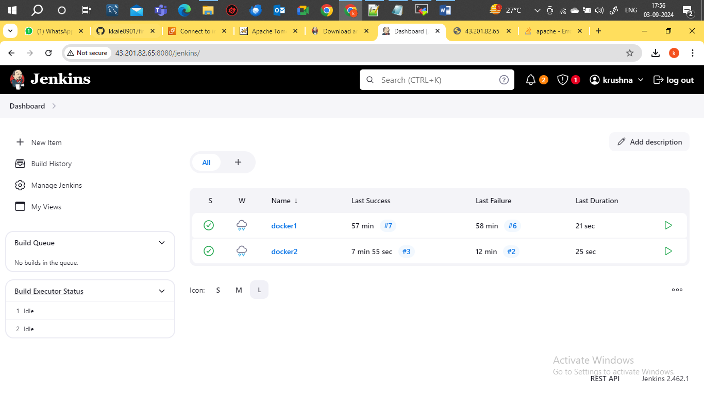

*script*

pipeline{

agent{

label{

label "built-in"

customWorkspace "/mnt"

}

}

stages{

stage("clean_repo"){

steps{

sh "rm -rf 2024Q*"

}

}

stage("clone_2024Q1"){

agent{

label{

label "built-in"

customWorkspace "/mnt/2024Q1"

}

}

steps{

sh "git clone https://github.com/kkale0901/firstRepo-Q1-release.git -b 2024Q1"

sh "chmod -R 777 /mnt/2024Q1/firstRepo-Q1-release/index.html"

}

}

stage("clone_2024Q2"){

agent{

label{

label "built-in"

customWorkspace "/mnt/2024Q2"

}

}

steps{

sh "git clone https://github.com/kkale0901/firstRepo-Q1-release.git -b 2024Q2"

sh "chmod -R 777 /mnt/2024Q2/firstRepo-Q1-release/index.html"

}

}

stage("clone_2024Q3"){

agent{

label{

label "built-in"

customWorkspace "/mnt/2024Q3"

}

}

steps{

sh "git clone https://github.com/kkale0901/firstRepo-Q1-release.git -b 2024Q3"

sh "chmod -R 777 /mnt/2024Q3/firstRepo-Q1-release/index.html"

}

}

stage("container_creation"){

steps{

sh "docker system prune -a -f"

sh "docker volume prune -a -f"

sh"docker volume create 2024Q1"

sh"docker volume create 2024Q2"

sh"docker volume create 2024Q3"

sh "docker run -dp 80:80 -v 2024Q1:/usr/local/apache2/htdocs --name 2024Q1 httpd"

sh "docker run -dp 90:80 -v 2024Q2:/usr/local/apache2/htdocs --name 2024Q2 httpd"

sh "docker run -dp 8090:80 -v 2024Q3:/usr/local/apache2/htdocs --name 2024Q3 httpd"

}

}

stage("deploy_index"){

steps{

sh "cp /mnt/2024Q1/firstRepo-Q1-release/index.html /var/lib/docker/volumes/2024Q1/_data"

sh "cp /mnt/2024Q2/firstRepo-Q1-release/index.html /var/lib/docker/volumes/2024Q2/_data"

sh "cp /mnt/2024Q3/firstRepo-Q1-release/index.html /var/lib/docker/volumes/2024Q3/_data"

}

}

}

}

Github repository

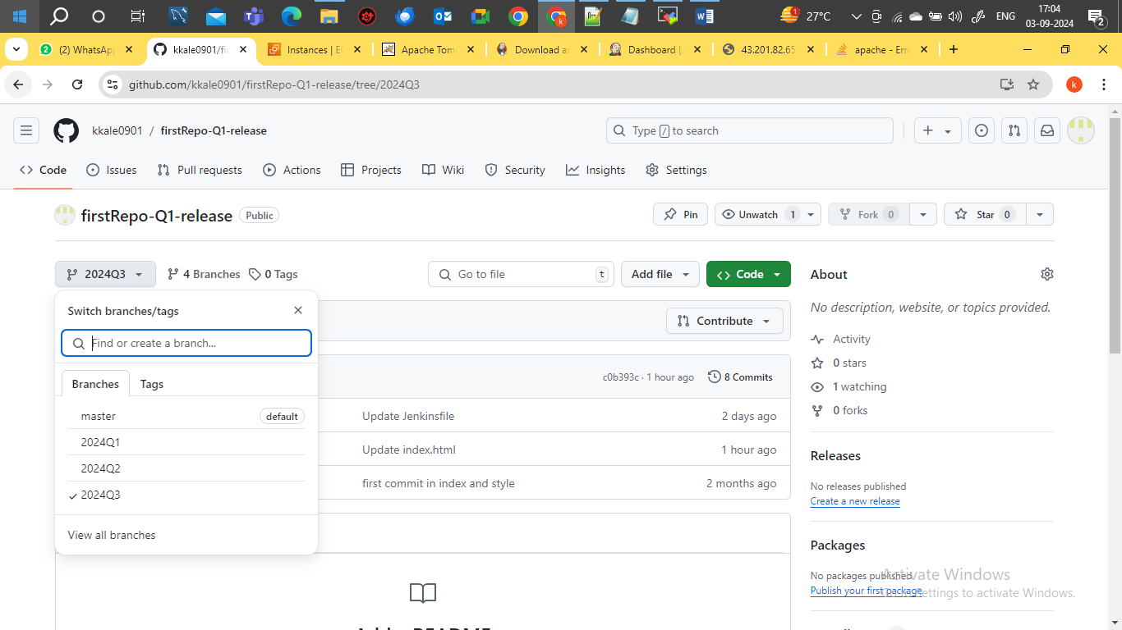

Job build successfully

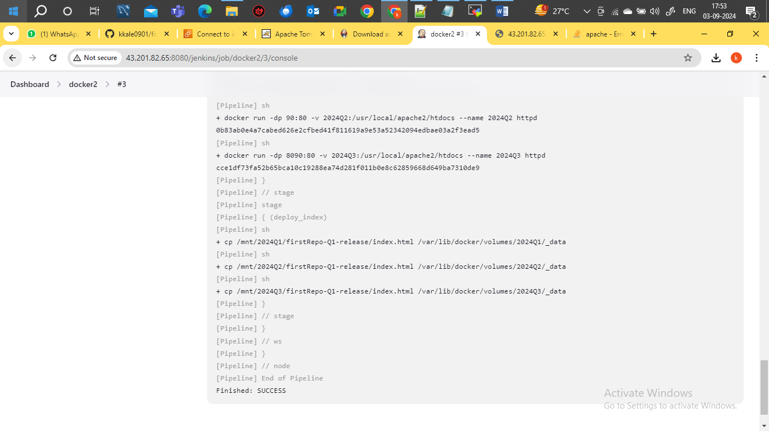

Three container and volume created using script

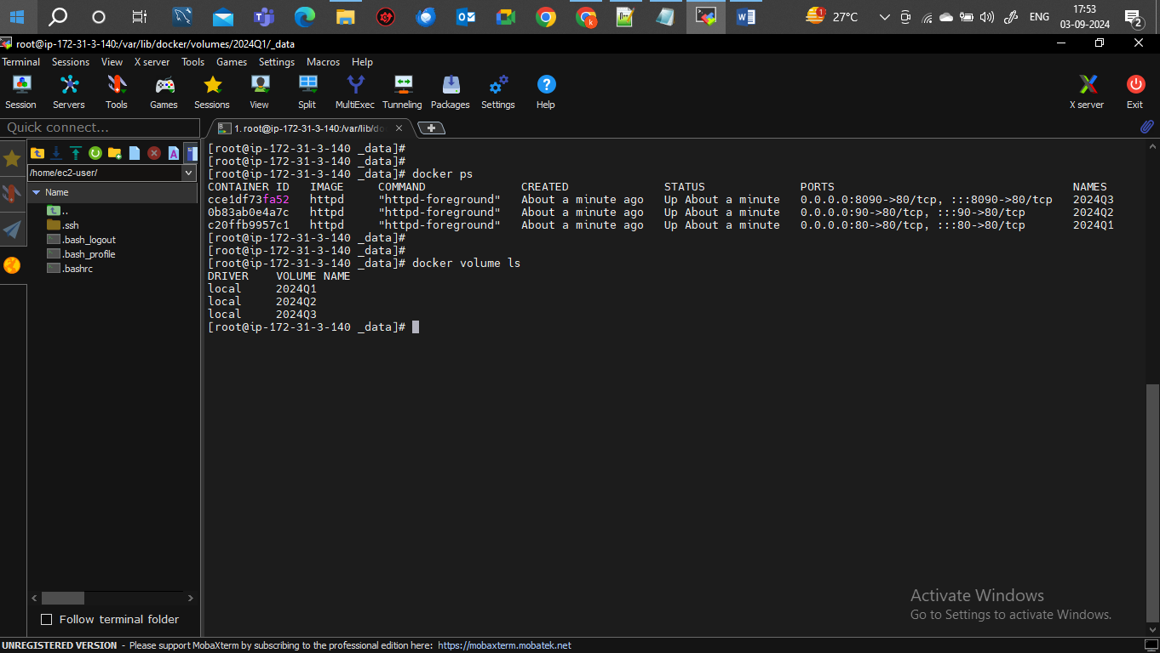

Port binding of 2024Q1 container with Ec2 instance port 80 and confirm the application host successfully

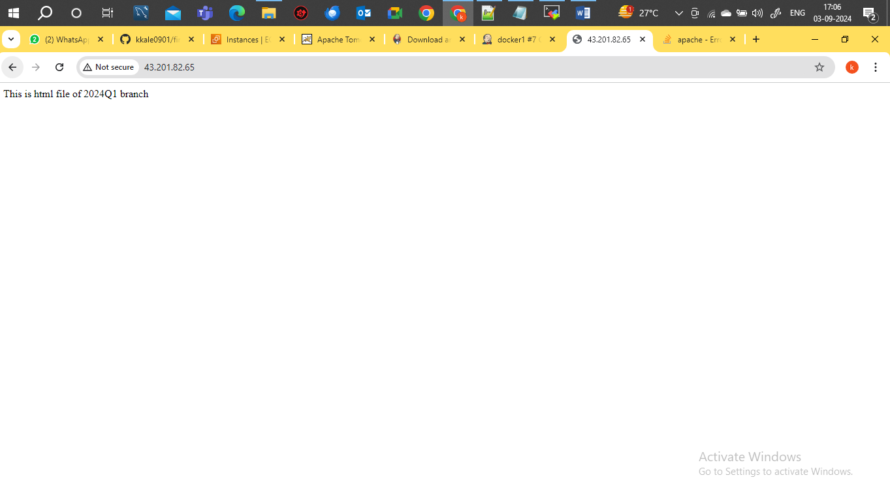

Port binding of 2024Q2 container with Ec2 instance port 90 and confirm the application host successfully

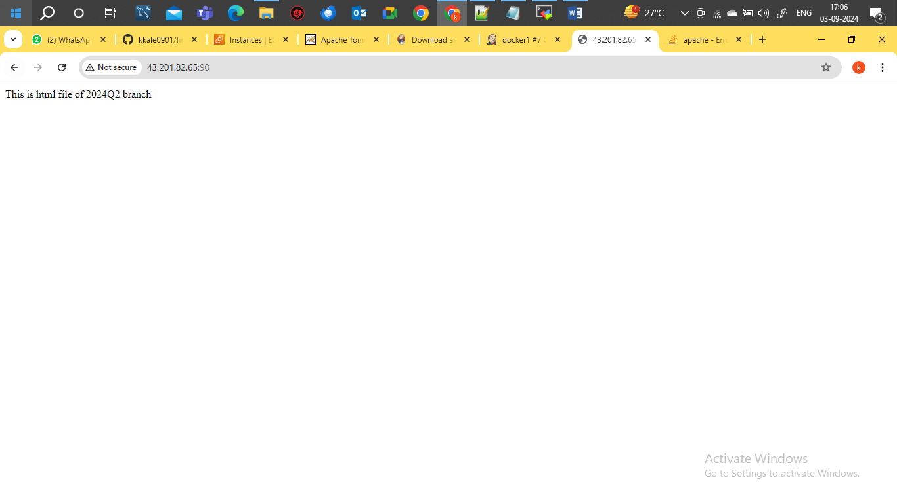

Port binding of 2024Q3 container with Ec2 instance port 8090 and confirm the application host successfully

